Group Project: Hotel booking system Week: Nov. 12-17, 2018

Task for the week:

* Created Git repository on: <https://github.com/hstnLaserna/AdUCpE_HotelBooking>
* Created initial HTML templates with CSS for reference of website
  + ‘images’ Directory : contains picture resources for the project
  + ‘styles’ Directory : contains the stylesheet.css file for the project.
  + ‘javascript’ Directory : contains the javascript files for the project.
  + logon.html : sample log-on page if user is not yet logged on.
  + home.html : home page which consists of clickable items for reference.
  + ref.html : sample landing page when a button from the menu is clicked.
  + rooms.html : sample landing page when the button from the menu is clicked.
  + stylesheet.css : contains css styles for the html.
  + index.js : contains javascripts for the logic of the html & sample json

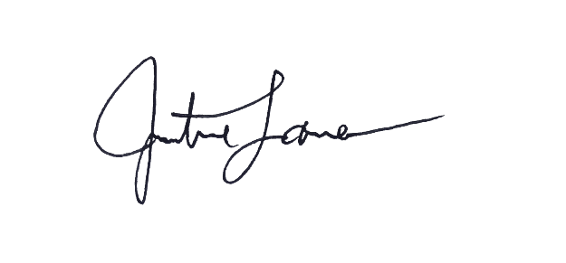

Justine Laserna

Person-in-charge